Chris Carrier WD 220

9/2/13 Chapter 1

Exercise 1-1

<!DOCTYPE html PUBLIC "-//W3C//DTD XHTML 1.0 Strict//EN"

"http://www.w3.org/TR/xhtml1/DTD/xhtml1-strict.dtd">

<html xmlns="http://www.w3.org/TR/html4/strict.dtd" lang="en">

<head>

<title>Interest Array</title>

</head>

<body>

<?php

$InterestRate1 = .0725;

$InterestRate2 = .0750;

$InterestRate3 = .0775;

$InterestRate4 = .0800;

$InterestRate5 = .0825;

$InterestRate6 = .0850;

$InterestRate7 = .0875;

$RatesArray = array($InterestRate1, $InterestRate2, $InterestRate3, $InterestRate4,

$InterestRate5, $InterestRate6, $InterestRate7);

echo "<p>The following are a list of Interest Rates: </p><p>";

echo "$RatesArray[0]<br />";

echo "$RatesArray[1]<br />";

echo "$RatesArray[2]<br />";

echo "$RatesArray[3]<br />";

echo "$RatesArray[4]<br />";

echo "$RatesArray[5]<br />";

echo "$RatesArray[6]</p>";

?>

</body>

</html>

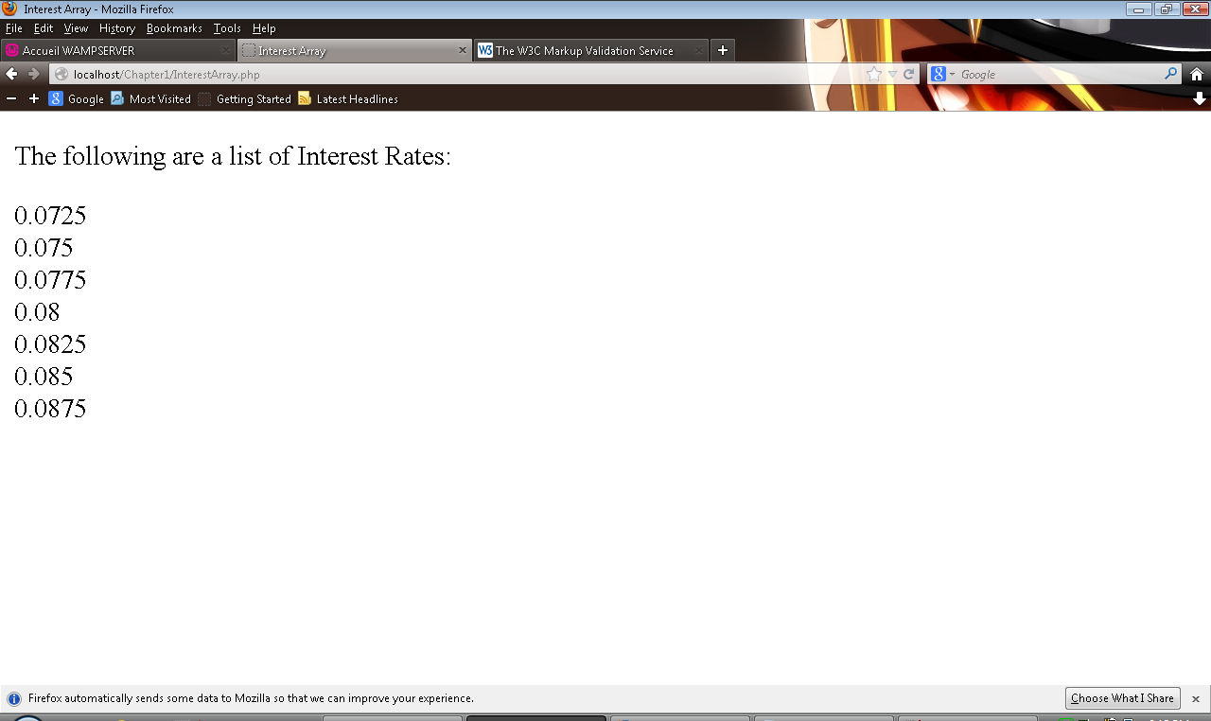

Exercise # 1-2

<!DOCTYPE html PUBLIC "-//W3C//DTD XHTML 1.0 Strict//EN"

"http://www.w3.org/TR/xhtml1/DTD/xhtml1-strict.dtd">

<html xmlns="http://www.w3.org/1999/xhtml">

<head>

<title>Return Value</title>

<meta http-equiv="content-type" content="text/html; charset=iso-8859-1" />

</head>

<body>

<?php

$Value1 = 2;

$Value2 = 3;

echo "<p>The following are the return value calculations: </p>";

echo '<p>$Value1 = 2 and $Value2 = 3', "<br />";

//1

$ReturnValue1 = ($Value1 == $Value2 ? "true" : "false");

echo '<p>1.) $Value1 is equal to $Value2 is: ', $ReturnValue1, "<br />";

//2

$ReturnValue2 = "2" + "3";

echo '<p>2.) $Value1 + $Value2 is: = "2" + "3" = ', $ReturnValue2, "<br />";

//3

$ReturnValue3 = ($Value1 >= $Value2 ? "true" : "false");

echo '<p>3.) $Value1 is greater than or equal to $Value2: ', $ReturnValue3, "<br />";

//4

$ReturnValue4 = ($Value1 <= $Value2 ? "true" : "false");

echo '<p>4.) $Value1 is less than or equal to $Value2: ', $ReturnValue4, "<br />";

//5

$ReturnValue5 = $Value1 + $Value2;

echo '<p>5.) $ReturnValue5 after addition expression is: ', $ReturnValue5, "<br />";

//6

$ReturnValue6 = ($Value1 >= $Value2) && ($Value1 > $Value2) ? "true" : "false";

echo '<p>6.) ($Value1 is greater than or equal to $Value2) AND ($Value1 is greater than $Value2): ', $ReturnValue6, "<br />";

//7

$ReturnValue7 = ($Value1 >= $Value2) || ($Value1 > $Value2) ? "true" : "false";

echo '<p>7.) ($Value1 is greater than or equal to $Value2) OR ($Value1 is greater than $Value2): ', $ReturnValue6, "<br />";

?>

</body>

</html>

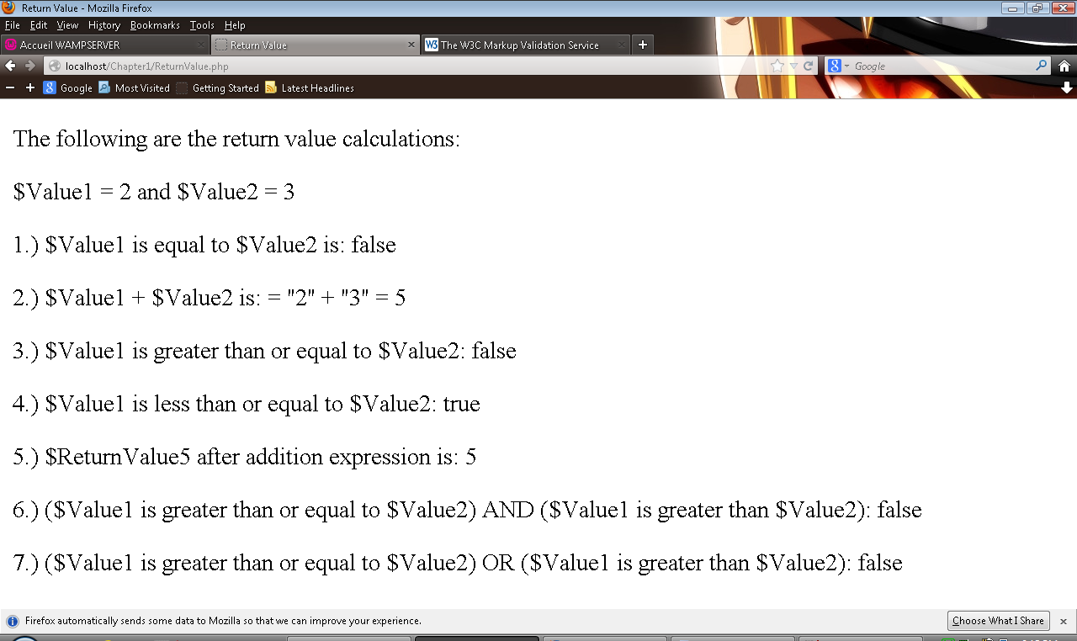

Exercise #1-3

<!DOCTYPE html PUBLIC "-//W3C//DTD XHTML 1.0 Strict//EN"

"http://www.w3.org/TR/xhtml1/DTD/xhtml1-strict.dtd">

<html xmlns="http://www.w3.org/1999/xhtml">

<head>

<title>Single Family Home</title>

<meta http-equiv="content-type" content="text/html; charset=iso-8859-1" />

</head>

<body>

<?php

$SingleFamilyHome = 399500;

$SingleFamilyHome_Display = number_format($SingleFamilyHome, 2);

echo "<p>The current median price of a single family home in Pleasanton, CA is $", $SingleFamilyHome_Display, ".<br />";

?>

</body>

</html>

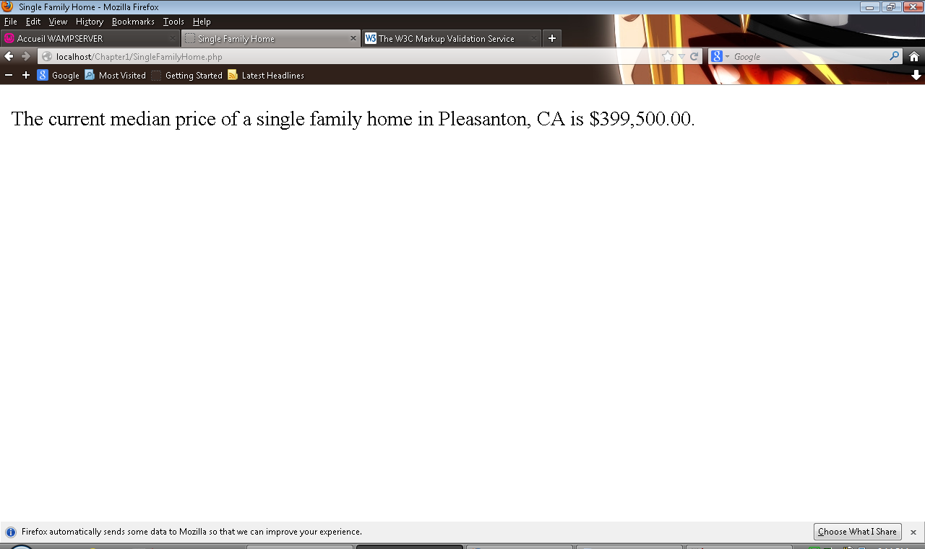

Exercise # 1-4

<!DOCTYPE html PUBLIC "-//W3C//DTD XHTML 1.0 Strict//EN"

"http://www.w3.org/TR/xhtml1/DTD/xhtml1-strict.dtd">

<html xmlns="http://www.w3.org/1999/xhtml">

<head>

<title>Days Arrays</title>

<meta http-equiv="content-type" content="text/html; charset=iso-8859-1" />

</head>

<body>

<?php

$EnglishDay1 = "Sunday";

$EnglishDay2 = "Monday";

$EnglishDay3 = "Tuesday";

$EnglishDay4 = "Wednesday";

$EnglishDay5 = "Thursday";

$EnglishDay6 = "Friday";

$EnglishDay7 = "Saturday";

$Days = array($EnglishDay1, $EnglishDay2, $EnglishDay3, $EnglishDay4,

$EnglishDay5, $EnglishDay6, $EnglishDay7);

echo "<p>The days of the week in English are: </p><p>";

echo "1.) $Days[0]<br />";

echo "2.) $Days[1]<br />";

echo "3.) $Days[2]<br />";

echo "4.) $Days[3]<br />";

echo "5.) $Days[4]<br />";

echo "6.) $Days[5]<br />";

echo "7.) $Days[6]</p>";

$FrenchDay1 = "Dimanche";

$FrenchDay2 = "Lundi";

$FrenchDay3 = "Mardi";

$FrenchDay4 = "Mercredi";

$FrenchDay5 = "Jeudi";

$FrenchDay6 = "Vendredi";

$FrenchDay7 = "Samedi";

$Days = array($FrenchDay1, $FrenchDay2, $FrenchDay3, $FrenchDay4,

$FrenchDay5, $FrenchDay6, $FrenchDay7);

echo "<p>The days of the week in French are: </p><p>";

echo "1.) $Days[0]<br />";

echo "2.) $Days[1]<br />";

echo "3.) $Days[2]<br />";

echo "4.) $Days[3]<br />";

echo "5.) $Days[4]<br />";

echo "6.) $Days[5]<br />";

echo "7.) $Days[6]</p>";

?>

</body>

</html>

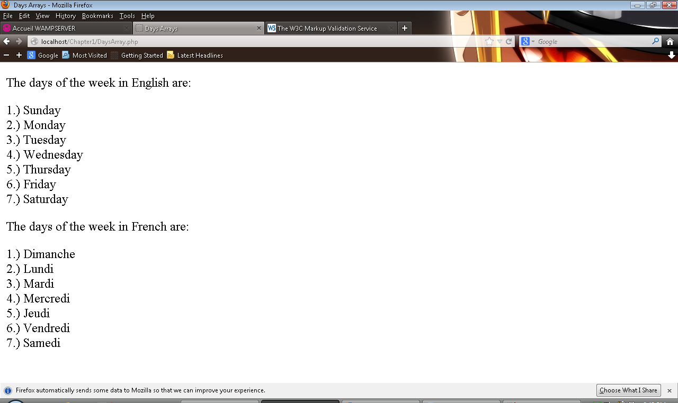

Exercise # 1-5

<!DOCTYPE html PUBLIC "-//W3C//DTD XHTML 1.0 Strict//EN"

"http://www.w3.org/TR/xhtml1/DTD/xhtml1-strict.dtd">

<html xmlns="http://www.w3.org/1999/xhtml">

<head>

<title>Rounded Values</title>

<meta http-equiv="content-type" content="text/html; charset=iso-8859-1" />

</head>

<body>

<?php

$Stock1 = 11.269; //round down

$Stock2 = 75.546; //round up

$Stock3 = 70.181; //floor - rounds down

$Stock4 = 160.799; //floor - rounds down

$Stock5 = 25.244; //ceil - rounds up

$Stock6 = 53.678; //ceil - rounds up

$WholeNumber1 = round($Stock1);

$WholeNumber2 = round($Stock2);

$WholeNumber3 = floor($Stock3);

$WholeNumber4 = floor($Stock4);

$WholeNumber5 = ceil($Stock5);

$WholeNumber6 = ceil($Stock6);

echo "<p>round() - rounds to the closest whole number. <br />";

echo "<p>ceil() - rounds up to the closest whole number. <br />";

echo "<p>floor() - rounds down to the closest whole numbers. <br />";

echo "<p>", $Stock1, " Rounds to: ", $WholeNumber1, "<br />"; //Rounds rounds down

echo "<p>", $Stock2, " Rounds to: ", $WholeNumber2, "<br />"; //Rounds - rounds up

echo "<p>", $Stock3, " Rounds to: ", $WholeNumber3, "<br />"; //Floor - rounds down

echo "<p>", $Stock4, " Rounds to: ", $WholeNumber4, "<br />"; //Floor - rounds down

echo "<p>", $Stock5, " Rounds to: ", $WholeNumber5, "<br />"; //Ceil - rounds up

echo "<p>", $Stock6, " Rounds to: ", $WholeNumber6, "<br />"; //Ceil - rounds up

?>

</body>

</html>

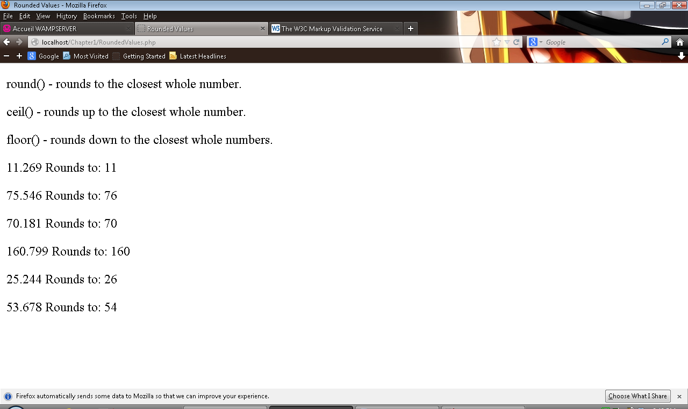

Exercise #1-6

<!DOCTYPE html PUBLIC "-//W3C//DTD XHTML 1.0 Strict//EN"

"http://www.w3.org/TR/xhtml1/DTD/xhtml1-strict.dtd">

<html xmlns="http://www.w3.org/1999/xhtml">

<head>

<title>Even Conditioning</title>

<meta http-equiv="content-type" content="text/html; charset=iso-8859-1" />

</head>

<body>

<?php

$NumberTest1 = 5.75;

$NumberTest2 = "H";

$NumberTest3 = 53.42;

$NumberTest4 = 58.33;

$NumberTest5 = 2;

$NumberTest6 = 14.23;

$NumberTest7 = "A";

$NumberTest8 = 55.46;

$Number1 = is_numeric($NumberTest1) ? "true." : "false.";

$Number2 = is_numeric($NumberTest2) ? "true." : "false.";

$Number3 = is_numeric($NumberTest3) ? "true." : "false.";

$Number4 = is_numeric($NumberTest4) ? "true." : "false.";

$Number5 = is_numeric($NumberTest5) ? "true." : "false.";

$Number6 = is_numeric($NumberTest6) ? "true." : "false.";

$Number7 = is_numeric($NumberTest7) ? "true." : "false.";

$Number8 = is_numeric($NumberTest8) ? "true." : "false.";

($NumberTest1 % 2 == 0) ? $Result1 = "This number is: even." : $Result1 = "This number is: odd.";

($NumberTest2 % 2 == 0) ? $Result2 = "This number is: even." : $Result2 = "This number is: odd.";

($NumberTest3 % 2 == 0) ? $Result3 = "This number is: even." : $Result3 = "This number is: odd.";

($NumberTest4 % 2 == 0) ? $Result4 = "This number is: even." : $Result4 = "This number is: odd.";

($NumberTest5 % 2 == 0) ? $Result5 = "This number is: even." : $Result5 = "This number is: odd.";

($NumberTest6 % 2 == 0) ? $Result6 = "This number is: even." : $Result6 = "This number is: odd.";

($NumberTest7 % 2 == 0) ? $Result7 = "This number is: even." : $Result7 = "This number is: odd.";

($NumberTest8 % 2 == 0) ? $Result8 = "This number is: even." : $Result8 = "This number is: odd.";

$Round1 = round($NumberTest1);

$Round2 = round($NumberTest2);

$Round3 = round($NumberTest3);

$Round4 = round($NumberTest4);

$Round5 = round($NumberTest5);

$Round6 = round($NumberTest6);

$Round7 = round($NumberTest7);

$Round8 = round($NumberTest8);

echo "<p>True = Number , False = Not Numeric <br />";

echo "<p>This number is: ", $Number1, "<br />";

echo $Result1, "<br />";

echo $NumberTest1, " Rounds to: ", $Round1, "<br />"; //Rounds

echo "<p>This number is: ", $Number2, "<br />";

echo $Result2, "<br />";

echo $NumberTest2, " Rounds to: ", $Round2, "<br />"; //Rounds

echo "<p>This number is: ", $Number3, "<br />";

echo $Result3, "<br />";

echo $NumberTest3, " Rounds to: ", $Round3, "<br />"; //Rounds

echo "<p>This number is: ", $Number4, "<br />";

echo $Result4, "<br />";

echo $NumberTest4, " Rounds to: ", $Round4, "<br />"; //Rounds

echo "<p>This number is: ", $Number5, "<br />";

echo $Result5, "<br />";

echo $NumberTest5, " Rounds to: ", $Round5, "<br />"; //Rounds

echo "<p>This number is: ", $Number6, "<br />";

echo $Result6, "<br />";

echo $NumberTest6, " Rounds to: ", $Round6, "<br />"; //Rounds

echo "<p>This number is: ", $Number7, "<br />";

echo $Result7, "<br />";

echo $NumberTest7, " Rounds to: ", $Round7, "<br />"; //Rounds

echo "<p>This number is: ", $Number8, "<br />";

echo $Result8, "<br />";

echo $NumberTest8, " Rounds to: ", $Round8, "<br />"; //Rounds

?>

</body>

</html>

